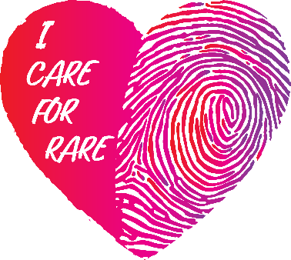
Via Courier/Email/Post
Name:
Date:
Address:

Dear (Insert Mr./Ms. Mayor here)
CC: (Insert names and titles of Municipal Council here)
Subject: Access to Community Housing, Community Supports for those living with Rare Disorders.
I Care for Rare is a social advocacy campaign, designed to give individuals, families and caregivers living with rare diseases an opportunity to achieve a collective voice for systemic healthcare AND community care support reform.
I Care for Rare is asking both the Federal Government to adopt and the Province of Ontario Government to amend the Health Protection and Promotion Act to include the needs of those suffering from rare diseases | disorders and immediately adopt the Private member Bill 129 and its recommendations set out in CORD’s 2017 Rare Disease Strategy as presented in 2017.
At the same time, Care for Rare Disease | Disorders crosses many different “systems” including municipal housing and community care supports.
Families are not equipped to navigate today’s complexity in accessing supportive housing and community care supports that enable them to have the same quality of life as others in the community.
Families and caregivers are struggling daily to manage the care of their loved ones for years alone and in silence. Often, they must leave the workforce to support their patient family member in isolation.
- Rare diseases | disorders are one of Canada’s biggest public health challenges on par with diabetes and cancer.
- Provincial ministries manage access to community supports and healthcare services.
- Municipalities are responsible for community housing.
- Municipalities offer community supports to the disabled that discriminate based on age and independence.
- About half of those with rare diseases and disorders are children. This number is growing as new technologies are enabling hundreds of new diagnoses.
- The percentage of those with rare diseases, disorders is about the same number of those at risk for mental illness (8%).
CORDS Canada’s Rare Disease Strategy lays out a five-point action plan:
- Improve early detection and prevention.
- Get the right care to patients as early as possible.
- Enhance community support.
- Provide sustainable access to promising therapies, and
- Promote innovative research.
The evidence is here: https://www.ipsos.com/en-ca/canadian-rare-disease-patients-and-direct-caregivers-experience-major-hurdles-timely-diagnosis-care
I would be happy to sit down with you at anytime to speak to you about why this is an urgent need for families and patients. There is a and need for municipalities to consider creative and inclusive supportive housing models.

Best Regards,
(Insert Signature here)

I Care for Rare, Social Advocacy Campaign

